HackerRank Quiz Questions

(Reinforcement Learning and Deep Learning)

**Q1. Now let’s revise the previous slides. We have learned that:**

* **A neural network is a (crude) mathematical representation of a brain, which consists of smaller components called neurons.**
* **Each neuron has an input, a processing function, and an output.**
* **These neurons are stacked together to form a network, which can be used to approximate any function.**
* **To get the best possible neural network, we can use techniques like gradient descent to update our neural network model.**

**Given above is a description of a neural network. When does a neural network model become a deep learning model?**

A. When you add more hidden layers and increase depth of neural network

B. When there is higher dimensionality of data

C. When the problem is an image recognition problem

D. None of these

**Solution: (A)**

More depth means the network is deeper. There is no strict rule of how many layers are necessary to make a model deep, but still if there are more than 2 hidden layers, the model is said to be deep.

**Q2. Given below is an input matrix named I, kernel F and Convoluted matrix named C. Which of the following is the correct option for matrix C with stride =2 ?**

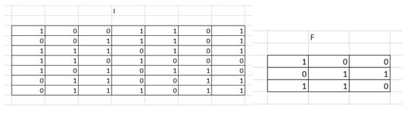

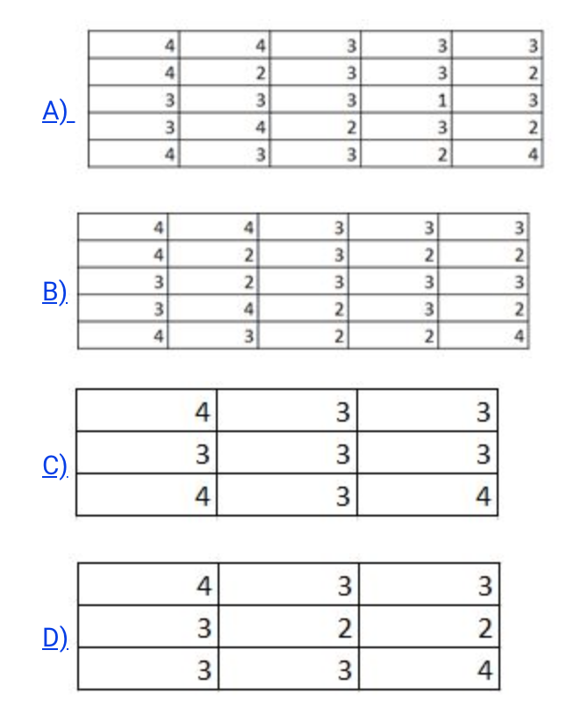

**Solution:**

1 and 2 are automatically eliminated since they do not conform to the output size for a stride of 2. Upon calculation option 3 is the correct answer.

**Q3. Q-learning can learn the optimal Q-function Q∗ without ever executing the optimal policy.**

1. **True**
2. **False**

**Solution:** True. It may not even be able to represent the optimal policy

**Q4: MDPs For this question, assume that the MDP has a finite number of states.**

**(i) [true or false] For an MDP (S, A, T, γ, R) if we only change the reward function R the optimal policy is guaranteed to remain the same.**

**(ii) [true or false] Value iteration is guaranteed to converge if the discount factor (γ) satisfies 0 < γ < 1.**

**(iii) [true or false] Policies found by value iteration are superior to policies found by policy iteration.**

**(iv) [true or false] If an MDP has a transition model T that assigns non-zero probability for all triples T(s, a, s0) then Q-learning will fail.**

**Q5. What is the significance of Pooling layers?**

1. **It helps in dimensionality reduction.**
2. **It is invariant to transformations of rotation and translation.**
3. It helps in regularization
4. None of the above